BASIC PROGRAMMING
CHAPTER 1 - INDIVIDUAL PRACTICAL ASSIGNMENT
STUDENT REPORT TEMPLATE
Assignment 1.1: Profile of a Tax Consultant & Tax Services

Student Information
Student Name : Garini SahasraKirana
Student ID (NIM) : 4.41.25.9.06
Class / Semester :KA-2IUP
Study Program : Computerize accounting
Submission Date : 14-9-2026

Course Lecturer
Ahmad Wafa Mansur, S.ST., M.IM.
Computerized Accounting Study Program
Department of Accounting, Politeknik Negeri Semarang

Report Instructions
Complete only the sections below using your own Assignment 1.1 work. Keep explanations concise, use readable evidence, and export the completed report to PDF.

1. Assignment Information
Assignment
Project Folder | week_1/tax_consultant_profile/
Main File | week_1/tax_consultant_profile/index.html
Repository Link | [Type here, if requested]

2. HTML Source Code
Paste the final HTML code from Assignment 1.1. Use consistent indentation. Additional pages may be used if required.
[Paste the final Assignment 1.1 HTML code here]
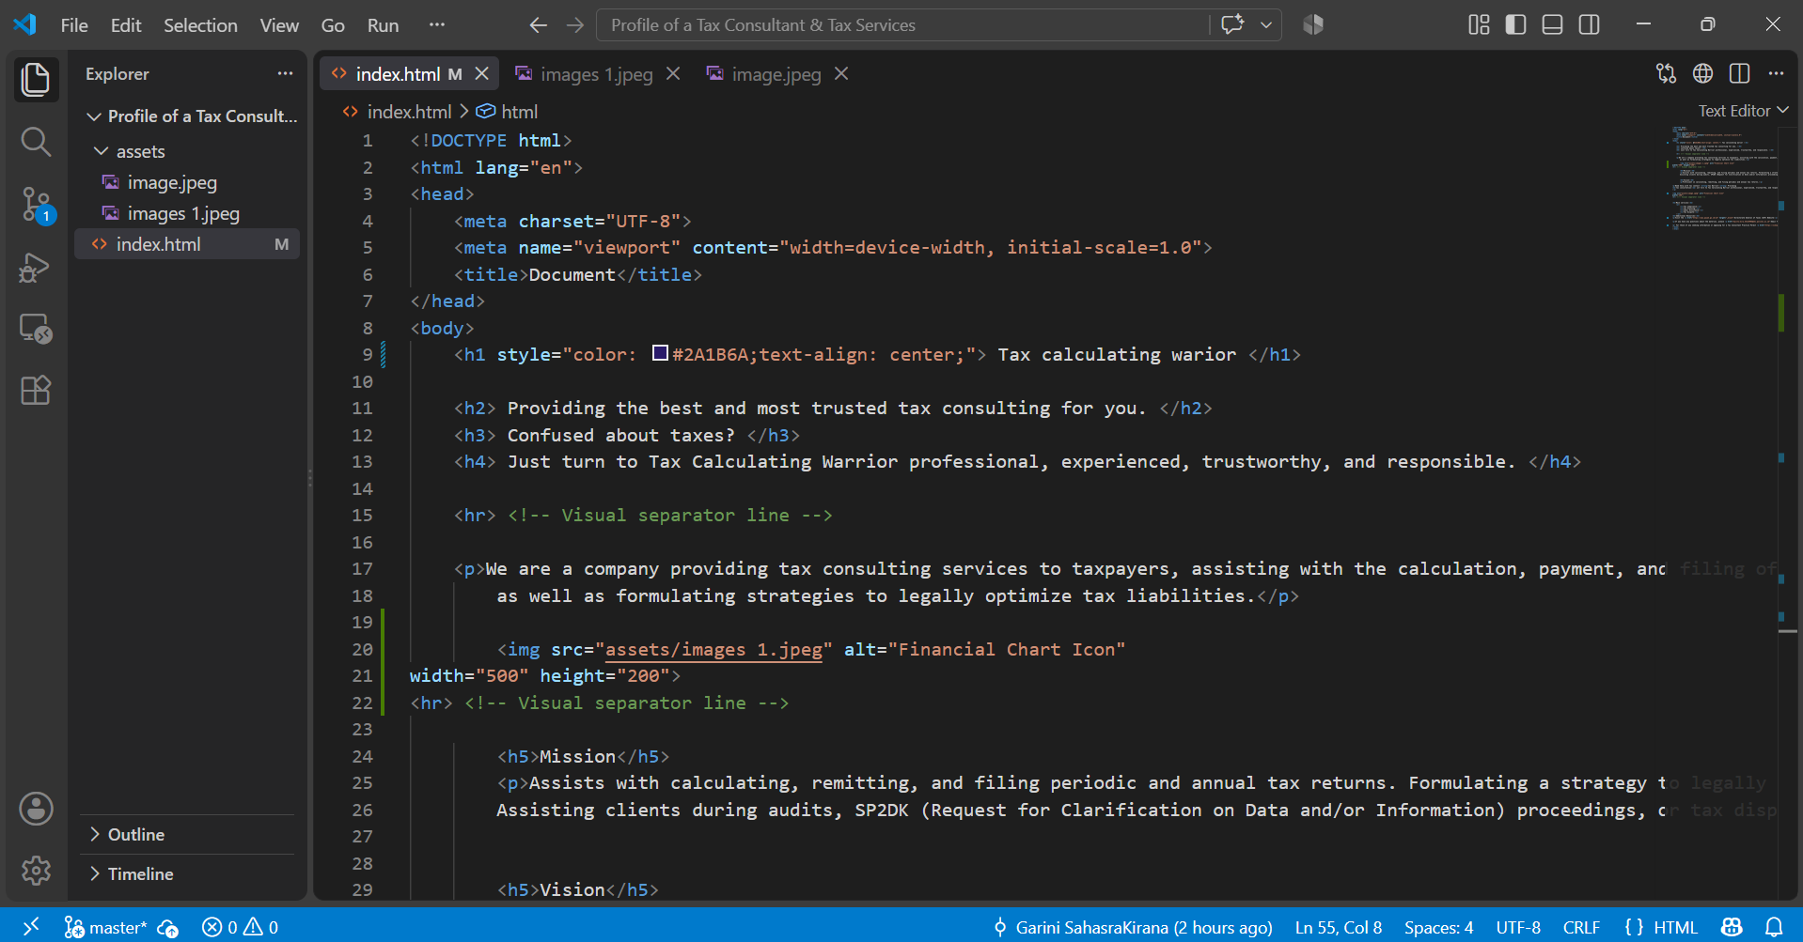
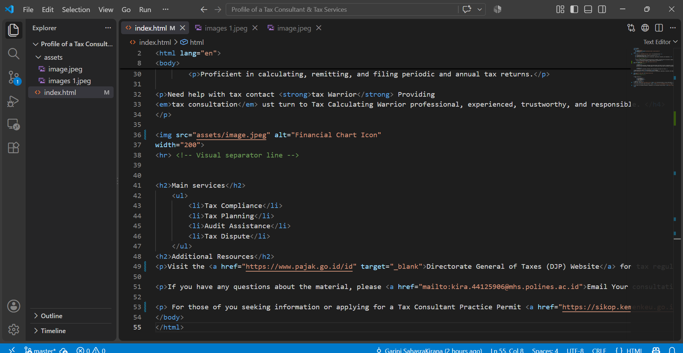

3. Browser Result
Insert one or two readable screenshots showing the completed page and its required elements.
[Insert screenshot here]
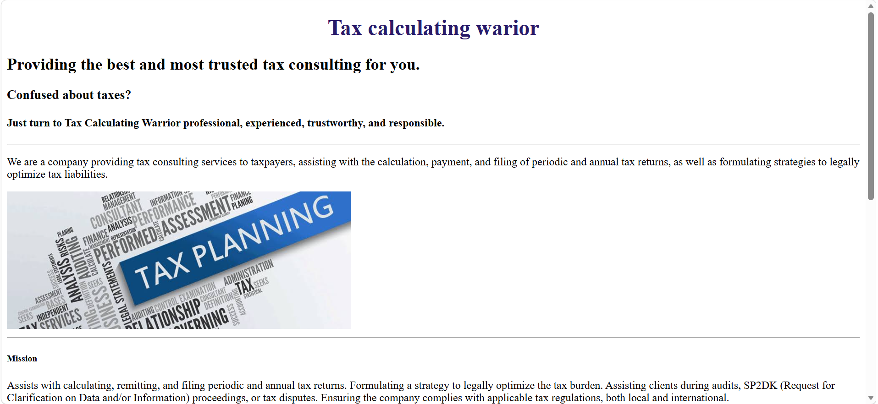
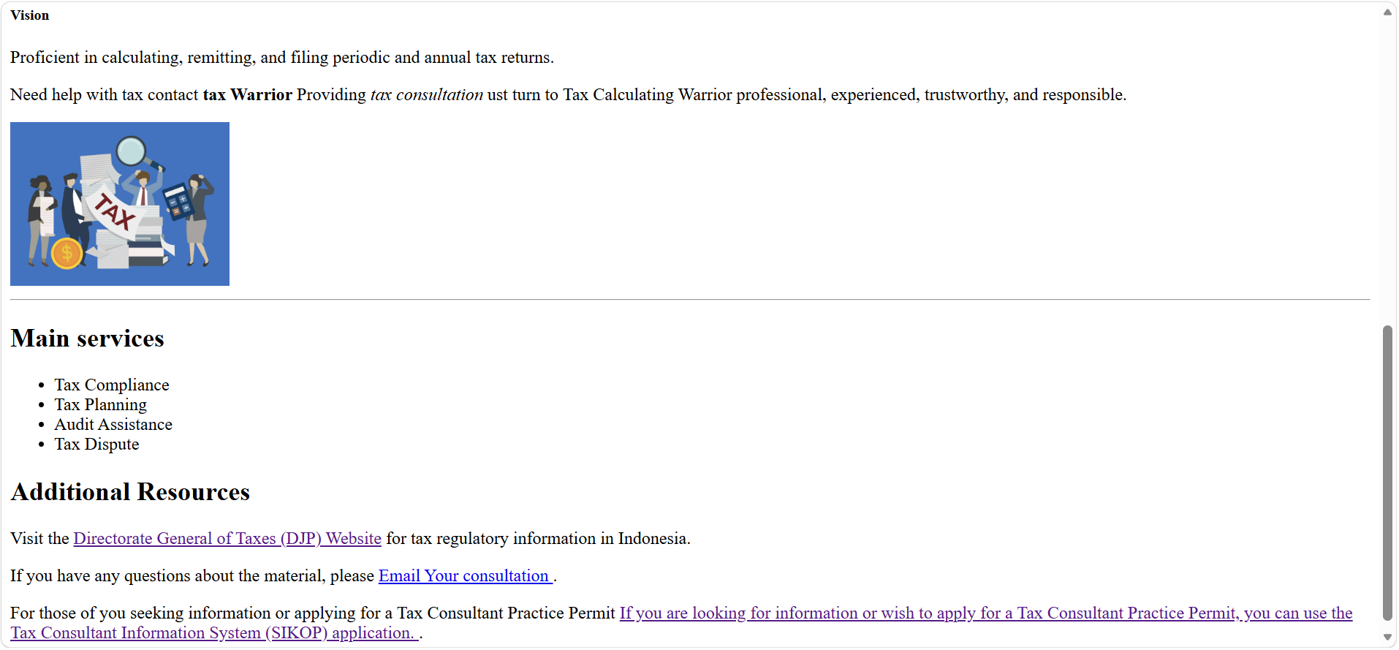

Caption: [Briefly describe what is shown]

3. Browser Result (continued)
[Insert screenshot here or write N/A]

Caption: [Briefly describe the tested links or elements]

4. Git Evidence
Insert one terminal screenshot showing the final Assignment 1.1 commit in git log.
Git Log Screenshot
[Insert terminal screenshot showing git log --oneline here]
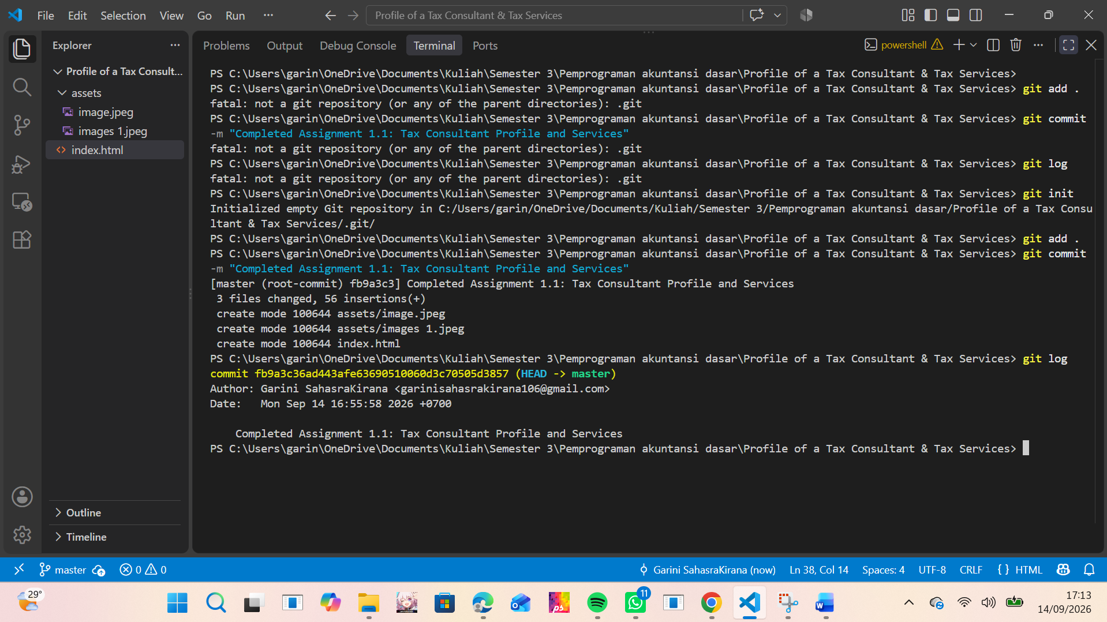

Commit hash: [Type here]
Commit message: Completed Assignment 1.1: Tax Consultant Profile and Services

5. Conclusion
Short Conclusion
HTML Profile Page Completed: Built a tax consultant web profile in index.html meeting all mandatory element specifications (headings, paragraphs, images with alt, external links, contact links, lists, formatting, and horizontal rules).
Git Repository Initialized: Successfully initialized a local repository using git init within the project folder.
Changes Staged & Committed: Registered all project files (git add .) and saved the final snapshot (git commit) with a proper commit message.
Verification Confirmed: Verified the commit history via git log, securing an authentic commit hash under your identity and transitioning VS Code file indicators from unstaged to clean.

6. Final Checklist
☐ Student identity is complete.
☐ Final Assignment 1.1 HTML code is included.
☐ Browser screenshot(s) clearly show the completed page.
☐ The final Assignment 1.1 commit appears in the Git screenshot.
☐ The report has been checked and exported to PDF.
Student Name | Student Signature | Lecturer Signature
[Type here] | [Sign here] | [Sign here]

